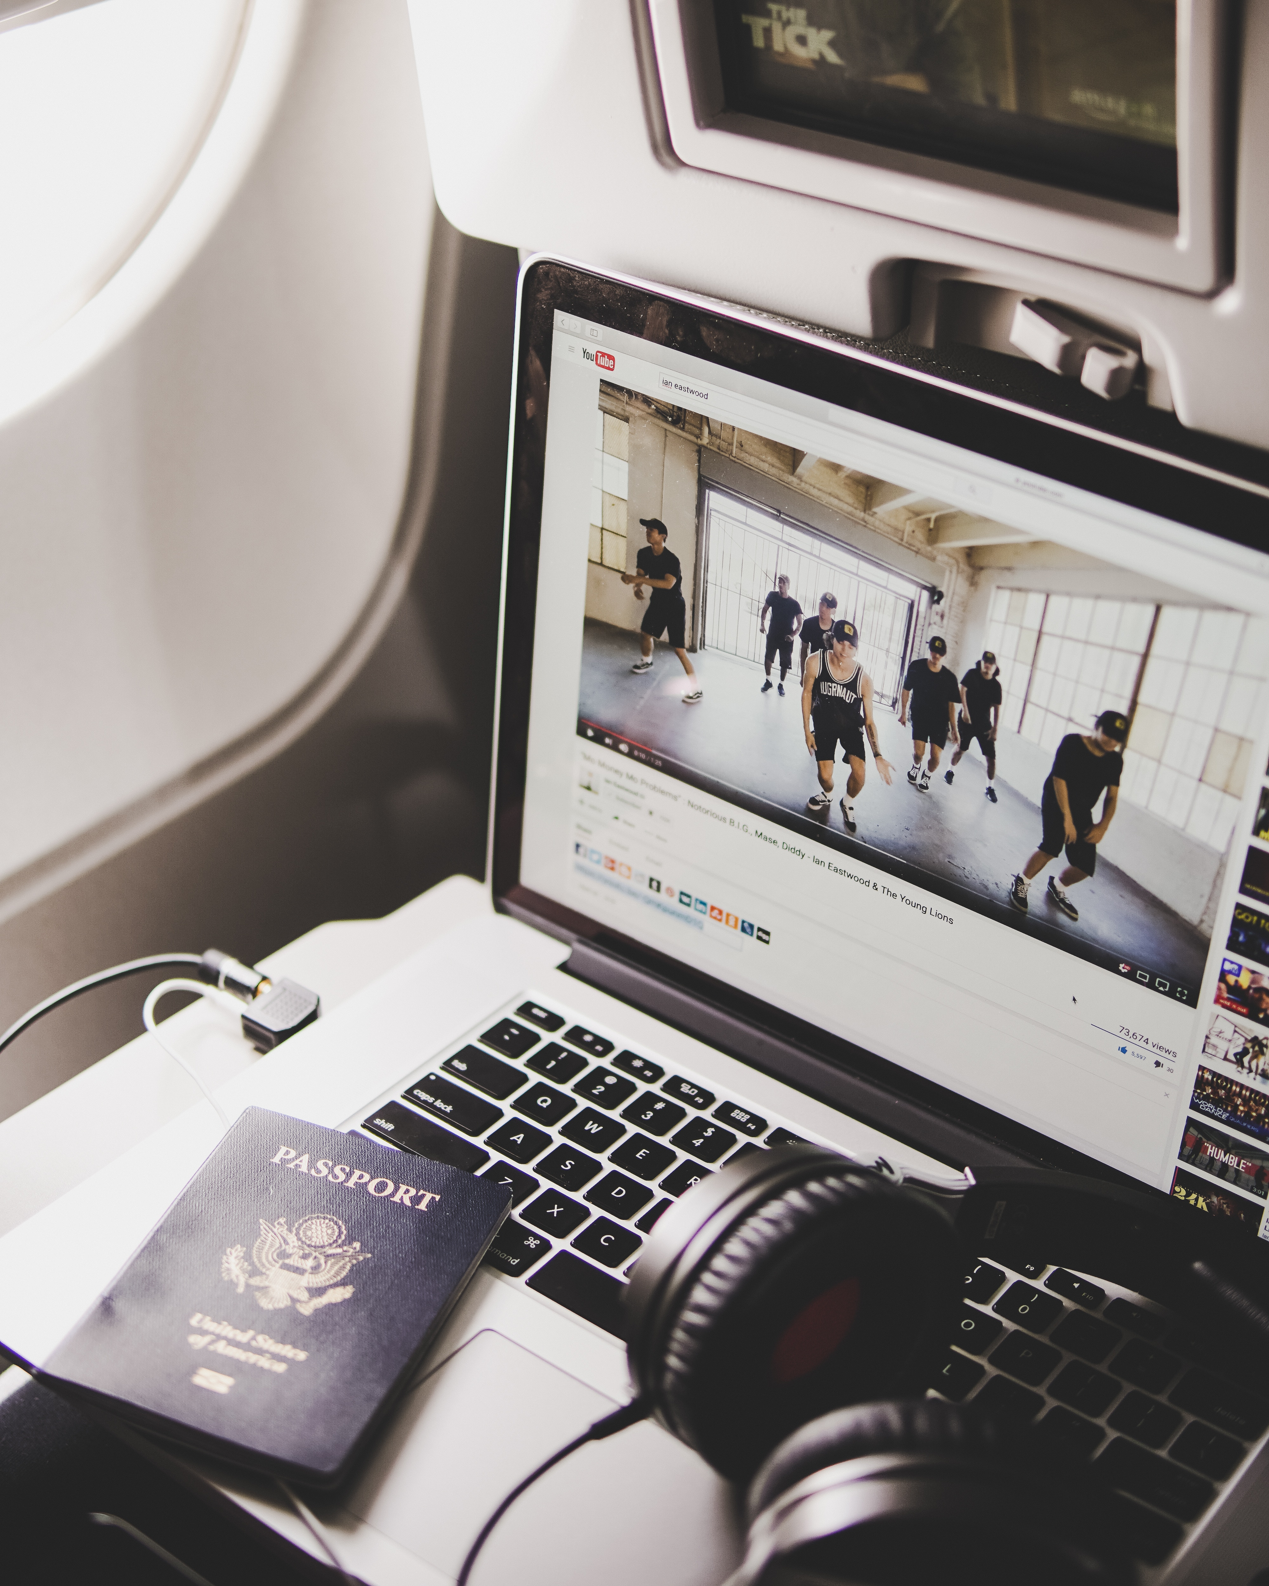

Contact me on:

Facebook: Nidhogg Tatoveringsstudio or

Annlaug Maria Tolo

* **Travel checklist for traveling with a new tattoo**:
* Bring sunblock lotion SPF 70 or above
* Bring UV proof clothing
* Check the weather before leaving
* Bring perfume free baby wipes to clean your tattoo on the go
* ALWAYS wash your hands before handling your tattoo
* Take vitamins and drink water to help you immune system cope