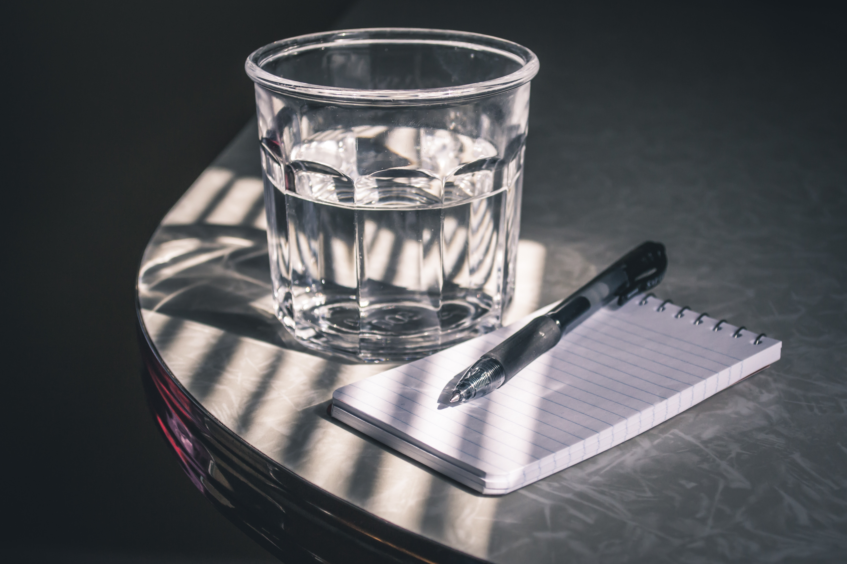

* **Prepare for your tattoo appointment**:
* Bring food and drink. If you don’t eat during your session your body will struggle as your blood sugar plummets. It will be much more painful to get tattooed if you don’t eat and drink properly during your session.
* Wear loose, comfortable clothing that you don’t mind spoiling: tattooing gets messy and sometimes we spill tattoo pigment and such things on our clients clothing.
* Make sure you have enough time set aside on the day of. Things take time and we cannot help you if you have a scheduled day after your tattoo session. To avoid stress and annoying situations: make sure to have an open schedule on the day you get tattooed.
* Bring a headset or any little book or gadget that might make you comfortable or pass the time. Please check with your tattoo artist before using it during your session though.
* Try to get a good nights sleep the night leading up to your tattoo session
* DO NOT show up hang over. The pain will be much worse and you will “bleed out” the ink making tattooing very difficult or even impossible.
* Ta vitaminer og drikk vann for å hjelpe kroppen på vei med å takle den nye tatoveringen og reisen

Contact me on:

Facebook: Nidhogg Tatoveringsstudio eller

Annlaug Maria Tolo